**Migratory situation in October – arrivals in Eastern Mediterranean down from September**

2019-11-12

In October, the number of detections of illegal border crossings on Europe’s main migratory routes fell 17% from the previous month to around 16 800 due to a drop in arrivals on the Greek islands in the eastern Aegean. The total on all European migratory routes for the first 10 months of 2019 was 16% lower at 107 900.

**Eastern Mediterranean**Even though the number of irregular migrants taking the Eastern Mediterranean route in October fell 18% from September to nearly 10 800*, it still accounted for two-thirds of all the detections of illegal border crossings into the European Union.

Despite the slowdown last month in large part due to worse weather conditions, the total number of detections in this region in the first 10 months of this year was 31% higher than a year ago at nearly 63 000.

In 2019 on the Eastern Mediterranean route, Afghans accounted for nearly one of every three migrants detected, while Syrians accounted for another quarter of the irregular migrants.

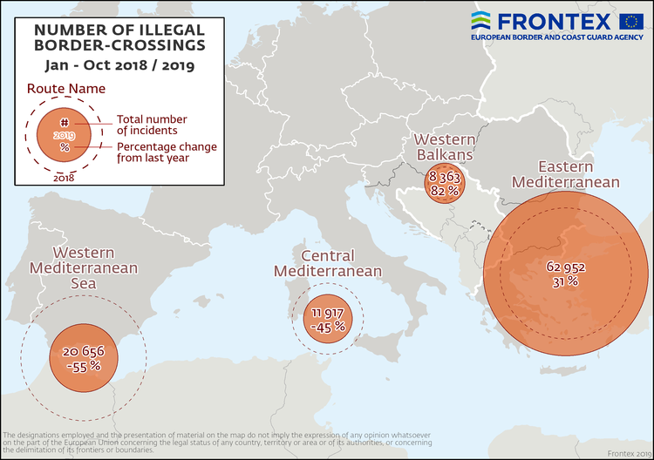

**Western Mediterranean**The number of irregular migrants crossing the Western Mediterranean in October rose 8% from the previous month to slightly more than 3 000.

The total for the January-October period stood at less than 21 200, less than half the figure from the same period of last year.

Moroccans and Algerians were the most represented nationalities on this route in the first 10 months of 2019.

**Central Mediterranean**The number of migrants passing through the Central Mediterranean in October stood at close to 2 050, or 27% less than in the previous month.

The total for the first 10 months of the year reached 11 900, down 45% from the same period of last year.

Nationals of Tunisia, Sudan, Côte d'Ivoire and Pakistan were the most represented nationalities on this route in the first 10 months of 2019.

**Western Balkans**There were more than 500 detections of illegal border crossings recorded on this route in October. The total for the first 10 months reached close to 8 400, 82% above the figure from a year ago.

Nationals of Afghanistan accounted for more than half of the migrants detected on this route.

*\*October 2019 data does not include the number of detections in Cyprus.*

*Note: The preliminary data presented in this statement refer to the number of detections of irregular border-crossing at the external borders of the European Union. The same person may attempt to cross the border several times in different locations at the external border.*